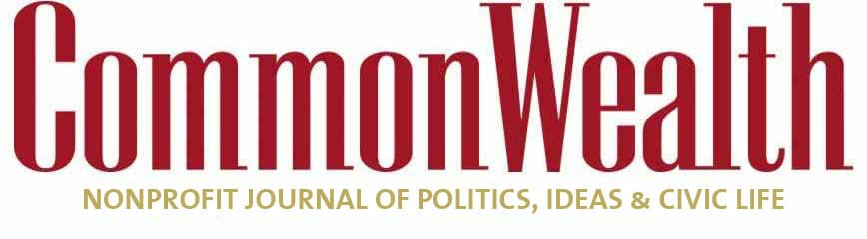

[ECONOMY](https://commonwealthmagazine.org/category/economy)**/**[STATE GOVERNMENT](https://commonwealthmagazine.org/category/state-government)**/**[OPINION](https://commonwealthmagazine.org/category/opinion)

**Secret ballot vital in union elections**

**Workers should be able to cast vote free of fear of retribution**

****[CHARLES CHIEPPO](https://commonwealthmagazine.org/author/charles-d-chieppo/)**Feb 13, 2023**

**THE LATEST** real-life parable that reminds us why the Founding Fathers made secret-ballot elections a centerpiece of American democracy comes from a distinctly 21st-century source – the video game industry.

In recent months, the Communication Workers of America (CWA) has been working to unionize Proletariat, a Boston-based studio owned by gaming company Activision Blizzard, which makes *Call of Duty*and *World of Warcraft.*They were supported by a group of pro-union employees called the Proletariat Workers Alliance.

CWA pressured Activision Blizzard to bypass the usual federally supervised secret-ballot election in favor of allowing employees to choose whether to unionize using an informal process known as “card check.” Under that system, organizers need only obtain cards endorsing unionization signed by a majority of the affected employees.

Needless to say, this non-confidential approach to union organizing provides virtually limitless opportunities for using intimidation and other questionable tactics to subvert democracy.

Thankfully, the company resisted the pressure and insisted on a secret ballot vote. Absent access to card check and the tactics it enables, it turns out that most Proletariat employees weren’t interested in what CWA was offering. In a surprise move, the Proletariat Workers Alliance withdrew its union petition on January 24.

If card check were allowed in this case, it’s entirely possible that Proletariat employees would have been coerced into unionizing, even though a majority of them opposed it.

Here in Massachusetts, organized labor gets plenty of help when it attempts to flout democratic principles in union representation elections.

Consider one example from the public sector. In 2018, the US Supreme Court ruled in *Janus v. American Federation of State, County and* *Municipal Employees* that public employees can’t be forced to join unions or pay union dues. The Commonwealth responded by passing legislation that allows public employee unions to agree to different terms for union members and non-members, giving unions the sole right to negotiate [lesser pay and reduced benefits](https://malegislature.gov/Laws/SessionLaws/Acts/2019/Chapter73) on behalf of the non-members.

The law also promotes tried and true intimidation tactics by giving unions access to employees’ [personal information](https://malegislature.gov/Laws/SessionLaws/Acts/2019/Chapter73), including home addresses; work, home, and personal cellphone numbers; along with work and personal email addresses. Anyone in Massachusetts public policy circles knows the Commonwealth’s unions aren’t interested in using that information to augment their holiday card lists.

Predictably, Sen. Elizabeth Warren joined CWA in urging Activision Blizzard to allow card check and [tweeted her support](https://twitter.com/SenWarren/status/1613580281818271744?s=20&t=9RalfjSCtyG_PaS_oXUzlA) for the effort to unionize Proletariat. To use a phrase she has made ubiquitous, in Massachusetts, it’s unions that have the kind of influence usually associated with “1 percenters.”

Despite the overwhelmingly pro-union political environment here, there had recently been hints that the organizing process wasn’t going smoothly at Proletariat. One employee, who spoke anonymously out of concern for retaliation by the union, told [Axios](https://www.axios.com/2023/01/12/activision-blizzard-proletariat-worker) that workers feel “disillusioned” by the high-pressure way their colleagues have sought to organize the workforce. “This is all being pushed faster than we’ve been able to process what it actually means for our jobs, who it applies to, what the benefits are versus the risks,” the worker said.

Pending federal legislation would ensure that employees considering whether to join a union have the opportunity to fully consider the ramifications of their decision, free of intimidation. The [Employee Rights Act](https://employeerightsact.com/), introduced by South Carolina Republican Sen. Tim Scott and Republican Rep. Rick Allen Georgia would guarantee most employees the right to a secret ballot in union elections, and protect workers’ personal information.

Not surprisingly, most Americans back these common-sense reforms. March 2022 polling found that [70 percent of respondents supported secret-ballot union elections](https://employeerightsact.com/wp-content/uploads/2022/03/220317_ERA_PublicSupport_2022.pdf). Interestingly, the number was even higher – 76 percent – among union households. Support for protecting employees’ personal information was [79](https://employeerightsact.com/wp-content/uploads/2022/03/220317_ERA_PublicSupport_2022.pdf) percent both overall and in union households.

Meet the Author

[](https://commonwealthmagazine.org/author/charles-d-chieppo/)

[**Charles Chieppo**](https://commonwealthmagazine.org/author/charles-d-chieppo/)

Guest Contributor

[Bio »](https://commonwealthmagazine.org/author/charles-d-chieppo/) [Latest Stories »](https://commonwealthmagazine.org/author/charles-d-chieppo/#author-posts-by)

American workers have the right to choose whether they want to be represented by a union. But those employees also have the right to a secret ballot so they can make that choice without fear of retribution.

*Charles Chieppo is the principal of Chieppo Strategies LLC, a Massachusetts public policy writing and communication firm.*